Order Of Service

Singing: Psalm 66—CW page 90

Reading: Psalm 112

Opening Hymn: CW 496

Reading: Acts 27:33-38

Request Hymn: CW Supplement 750

Reading: Matthew 13:1-9

Sermon Hymn: CW 363

Sermon Text: Mark 12:28-34

Close To God

Prayer

The Apostles’ Creed, TLH page 12

Holy Communion

The Lord's Prayer

The Blessing

Closing Hymn: CW 449

* * * * * * * * * * *

Koinonia Hour

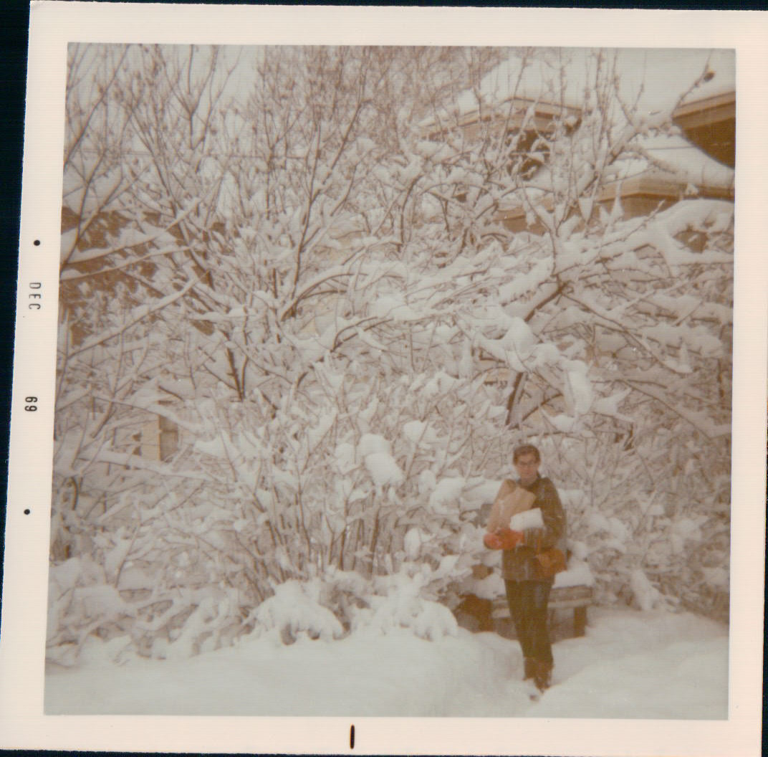

December In Duluth

Water
Of
Life

2 February 2020

W A T E R O F L I F E

Independent Christian Church—Conservative Lutheran Doctrine

Worship Service: 9:30 a.m. Bible Study: 10:45 a.m.

Larry Cooper, Pastor E-Mail address:
111 N. Ridge Road lcooper@wateroflife.cc
Coon Valley, WI 54623 Web Site:
www.wateroflife.cc

* * * * * * * * * * * * * * * * * * * * * * * * * * *

Sermon Text: Mark 12:28-34

Close To God

* * * * * * * * * * * * * * * * * * * * * * * * * * *

Mark 12:28 And one of the scribes came, and having heard them reasoning together, and perceiving that he had answered them well, asked him, Which is the first commandment of all?
:29 And Jesus answered him, The first of all the commandments is, Hear, O Israel; The Lord our God is one Lord:
:30 And thou shalt love the Lord thy God with all thy heart, and with all thy soul, and with all thy mind, and with all thy strength: this is the first commandment.
:31 And the second is like, namely this, Thou shalt love thy neighbour as thyself. There is none other commandment greater than these.

:32 And the scribe said unto him, Well, Master, thou hast said the truth: for there is one God; and there is none other but he:
:33 And to love him with all the heart, and with all the understanding, and with all the soul, and with all the strength, and to love his neighbour as himself, is more than all whole burnt offerings and sacrifices.
:34 And when Jesus saw that he answered discreetly, he said unto him, Thou art not far from the kingdom of God. And no man after that durst ask him any question.

Matthew 25:1-13

1 Then shall the kingdom of heaven be likened unto ten virgins, which took their lamps, and went forth to meet the bridegroom.
2 And five of them were wise, and five were foolish.
3 They that were foolish took their lamps, and took no oil with them:
4 But the wise took oil in their vessels with their lamps.
5 While the bridegroom tarried, they all slumbered and slept.
6 And at midnight there was a cry made, Behold, the bridegroom cometh; go ye out to meet him.
7 Then all those virgins arose, and trimmed their lamps.
8 And the foolish said unto the wise, Give us of your oil; for our lamps are gone out.
9 But the wise answered, saying, Not so; lest there be not enough for us and you: but go ye rather to them that sell, and buy for yourselves.
10 And while they went to buy, the bridegroom came; and they that were ready went in with him to the marriage: and the door was shut.
11 Afterward came also the other virgins, saying, Lord, Lord, open to us.
12 But he answered and said, Verily I say unto you, I know you not.
13 Watch therefore, for ye know neither the day nor the hour wherein the Son of man cometh.

